PRIMARY FOUR
R.E
LESSON NOTES
FOR
TERM ONE

THEME; CHRISTIANS WITH THE SAVIOUR
TOPIC: GOD’S CONTINUING LOVE FOR HIS PEOPLE

WEEK: 2 LESSON 1
THE CREATION STORY
Gen 1:1-27
- To create means to make something exist or happen.
- The word creation can also mean the earth and all things in it.

- What does the word Genesis mean?
Genesis means the beginning.

- In the beginning, God created the universe.
- The universe are the things like the sky, the moon, the stars, the earth and all things on it like; water, plants animals , mountains etc.
- God took six days to create the universe.
The order of creation
DAY | CREATION
First day | Light
Second day | The sky
Third day | Land, sea and plants that grow on the land
Fourth day | Sun, moon and stars
Fifth day | Birds, fish and other aquatic animals
Sixth day | All land animals and man
Seventh day | A day of rest

- Why did God make man in His own image and likeness?
- To worship Him
- To look after God’s creation
- To procreate ( to continue with the work of creating)

Activity
- In which book do we find the creation story?
- On which day did God crate light?
- On which day did God create man?
- State any two reasons why man was created in the image of God?
- Draw and name any three sources of light God created.

WEEK: 2 LESSON 2
CARING FOR GOD’S CREATION
Man was given a duty to look after all the things that God created.
These include;

- plants
- animals
- land
- birds
- swamps
- forests

Ways of caring for God’s creation
- Planting trees
- Keeping water bodies clean
- Controlling deforestation
- Practicing good farming methods
- Keeping the environment clean
- Taking care of ourselves and other people
- Protecting animals and birds

Activity
- Mention any four things that man was commanded to look after.
- Suggest any four ways how man can look after God’s creation.

WEEK: 2 LESSON 3
THE FALL OF MAN/HUMAN BEINGS
Gen 3:1-13
- Adam and Eve first lived in the Garden of Eden.
- God commanded them not to eat of the tree in the middle of the garden.
- This tree was of knowledge of good and evil.
- The snake/ serpent tempted Eve to eat the forbidden fruit.
- She ate and also gave to Adam to eat.

Results/consequences for disobeying God
Gen 3:14-23
- They realized they were naked
- They were afraid and hid
- They lost the good relationship with God
- They were cursed
- They were chases from the garden
- Suffering

Activity
- In which garden did Adam first live?
- Which creature tempted Eve to eat the forbidden?
- Mention any three things that resulted from man’s disobedience in Eden.

WEEK: 3 LESSON 1
God’s punishments to Adam, Eve and the snake
Gen 3:14-24
- Adam and Eve committed the first sin by eating the forbidden fruit.
- What is sin?
Sin is any act against God’s will.

- God punished them as follows;
a)Adam(the man)
- To work hard for food
b) Eve (the woman)
- To give birth in pain
c) The snake
- To eat dust
- To crawl on its belly

Activity
- What is sin?
- What was the first sin to be committed by man?
- Which punishment did God give these creatures:
- The woman
- The snake

WEEK: 3 LESSON 2
REPENTANCE
- What is repentance?
Repentance means feeling sorry for the wrong things you have done.
- when we sin, we should ask God for forgiveness
- Examples of sin are;

- fighting
- telling lies
- stealing
- worship of idols

- We should also repent/ confess when we offend our friends, parents, relatives and teachers.

Importance of repentance
- God forgives us
- It restores our friendship
- Removes anger

Examples of people from the Bible who repented are;
- The lost/ prodigal son(Luke15:11-32)
- King David
- Simon Peter

Activity
- What is repentance?
- Mention two examples of sin.
- Give two reasons why we should repent.
- What should you do when you offend your friend?

WEEK: 3 LESSON 3
THE PURPOSE OF JESUS’ COMING
The Coming of Jesus
Mark 1:1-8
Matt 1:18-20
- Through the sin of Adam and Eve, human beings continued to sin.
- God’s relationship with man was broken.
- God decided to send His only son Jesus as a savior.
- Jesus died on the cross for our sins to be forgiven.
- Jesus’ earthly parents were Joseph and Mary.
- John the Baptist is the prophet who prepared for Jesus’ coming.
- John the Baptist asked people to repent and baptized them in River Jordan.
Activity
- How did the sin of Adam and Eve affect us?
- How did God restore the relationship with man?
- Why did jesus die on the cross?
- Name the prophet who prepared for the coming of the Messiah?

WEEK: 4 LESSON 1
JESUS’ MISSION IN THE WORLD
Mark 1:21-28
- Jesus came into the world to save us from our sins.
- He saved us by dying on the cross.
- Through His death, if we confess our sins are forgiven.
- Jesus brought the good news and performed miracles

Miracles performed by Jesus
- Healing the sick
- Raised the dead(Lazarus and Jairus’ daughter)
- Healing the deaf, the dumb and the bind.
- Healed the lame
- Cast out demons
- Walked on water
- Fed 500 people on 2 fish and 5 loaves of bread.

Activity
- Why did Jesus come into the world?
- Mention any three miracle performed by Jesus.
- Name any two people that were raised to life by Jesus.

WEEK: 4 LESSON 2
JESUS AND ZACCHAEUS
Luke 19:1-10
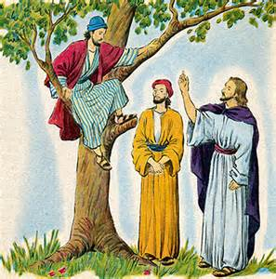

- Jesus was passing through the city of Jericho.
- Zacchaeus the chief tax collector climbed a Sycamore tree to see Jesus because he very short.
- Jesus ordered him to come down and visited his home.
- Zacchaeus promised to give half of his belongings to the poor.
- He also promised to pay back four times those he cheated.
- Jesus told him that He came to seek and save the lost.

Lessons from the story
- To pay back our debts
- To confess our sins
- To avoid cheating

Activity
- Through which town was Jesus passing?
- Who climbed a tree to see Jesus as he was passing by?
- Why is cheating bad?
- Who were the lost that Jesus came to seek?

WEEK: 4 LESSON 3
GOD’S PEOPLE IN THE LAW
Noah’s faithfulness
Gen 6:1-8
- God told Noah to build the big boat called the Ark.
- The Ark saved Noah, his family and other creatures from the flood.
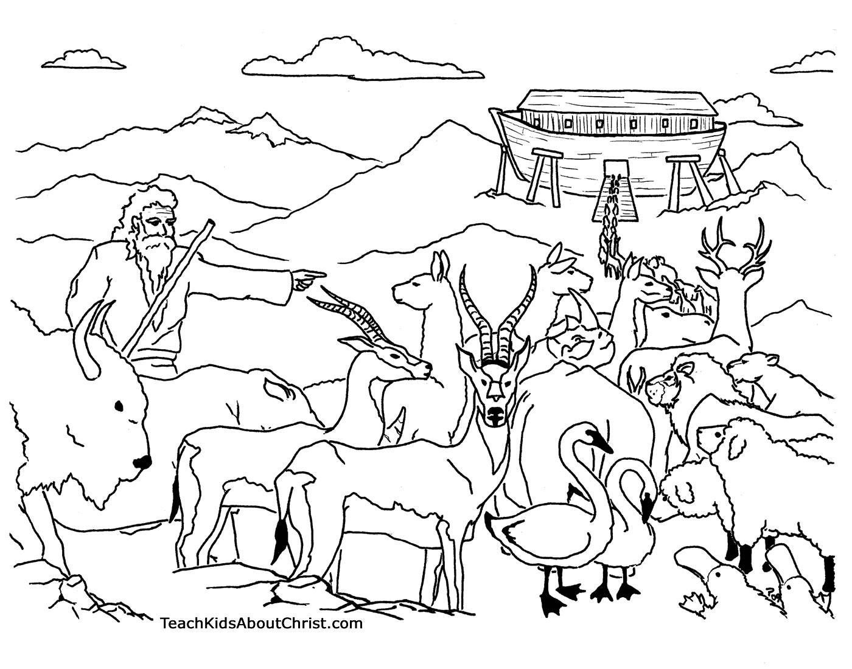

- It rained for 40 days and nights but it took 150 days for the floods to dry up.
- Noah sent a dove to check whether the floods had dried.
- The names of Noah’s sons were:
  - Shem
  - Ham
  - Japheth
- Only 8 people were saved from the floods.
- Noah’s ark rested on Mountain Ararat.

God’s covenant with Noah
- What is a covenant?
A covenant is an agreement between two people.
- God’ promised never to destroy all living things with floods.
- He made a rainbow as a sign of the covenant.

Activity
- Who built the ark?
- For how long was the flood in Noah’s time?
- Name the mountain where Noah’s Ark rested.
- Which covenant did God make with Noah?
- What was the sign of God’s covenant with Noah?

WEEK: 5 LESSON 1
GOD’S PROMISES TO ABRAHAM
Gen12, 17, Gen 17:7
- God made a covenant with Abraham and promised, ”I will be your God and you will be my people”
- Circumcision of every male was to be the sign of the covenant.
- Sarah and Abraham lived in the promised land of Canaan.
- Sarah gave birth to her son Isaac at an old age.
- God tested Abraham to sacrifice his only son, Isaac.
- Ishmael was Abraham’s first son through the servant Hagar.

God’s promises to Abraham
- God promised Abraham many grandchildren who would be a great nation.
- To make Abraham’s name great.
- To bless those who bless those who blessed Abraham.
- To curse those who cursed Abraham.
- To make him the father of all nations.
- To bless all people of the earth through Abraham

Why Abraham was made the father of all nations?
- He believed in all God’s promises.
- He was obedient.
- He was patient
- He trusted in God.

Activity
- To who did God say, ‘ I will be your God and you will be my people’?
- What was the physical sign of God’s covenant with Abraham?
- Name the two sons of Abraham.
- Which land was promised to Abraham?
- Mention any three promises god gave to Abraham.

WEEK: 5 LESSON 2
GOD’S PROMISES TO JACOB
Gen27:1-31
- Jacob was a son of Isaac and Rebecca.
- He was a grandson of Abraham.
- Jacob’s twin brother was Esau.
- Jacob stole his brother, Esau’s blessing.(birthright)
- What does the name Jacob mean?
A cheat/ liar
6. When Jacob wrestled with the angel of the lord, his name was changed to Israel.

God appeared to Jacob and made the following promises;
- To give him the land of Canaan.
- To give him many descendants.
- To protect him
- To bless all nations through him.
- To bless those who blessed Jacob and curse those who curse him.

Activity
- Name the parents of Jacob.
- What does the name Jacob mean?
- Who was Jacob’s twin brother?
- Give any two promises that were made to Jacob and Abraham.

WEEK: 5 LESSON 3
MOSES AND THE EXODUS
Moses’ call (Exodus 3)
- Moses at first was a shepherd.
- Moses’ father was Amram and his mother was Jochebed.
- God first appeared to Moses in form of a burning bush.
- This was at the foot of Mt Sinai ( Horeb).
- God told Moses to remove his sandals because he was standing on a holy ground.
- God told Moses that his name was ‘Iam.’
- He sent Moses to rescue the Israelites from Egyptian slavery.
- Aaron was made to be Moses’ spokesman.

Why did Moses refuse God’s call at first?
- He was a poor speaker.
- He had killed an Egyptian
- It was his first time to talk to God.

Signs God gave to Moses.
- To throw down his stick and it would turn into a snake
- To turn the water into blood.
- To put his arm into his chest and it would turn leprous.

Activity
- Name the mountain were God first met Moses.
- Why did God call Moses?
- Why was Moses told to remove his shoes?
- In which form did God appear to Moses?
- Name two miracles that Moses performed before pharaoh.

WEEK: 6 LESSON 1
THE EXODUS
- The word Exodus means departure or going out.
-It was used to mean the journey of the Israelites from Egypt to the promised land.
- Canaan was the promised land for the Israelites.
- Pharaoh was the title given to the ancient kings of Egypt.
- Moses led the Israelites out of Egypt across the Red sea.
- Moses used his stick to divide the waters of the Red sea.
- Moses died on Mt Nebo before reaching the promised land.
- Joshua succeeded Moses and led the Israelites to the promised land.
- Joshua led the Israelites from the desert across R. Jordan.

God’s punishments to the Egyptians
- Turning of the water of the Nile into blood.

- Frogs
- Flies
- Darkness
- Death of animals
- Boils
- hail storms
- locusts
- Death of the first born males.

10. What was the last plague?
Death of the first born males (sons and animals)
- God Provided manna and quails as food

Activity
- What does the term ‘Exodus’ mean?
- What was the Promised Land for the Israelites?
- Name the water body that was crossed by the Israelites from Egypt.
- On which mountain did Moses die?
- Who led the Israelites to the promised land?
- List down any other four plagues that faced the Egyptians.
- Which type of food did the Israelites eat in the wilderness?

WEEK: 6 LESSON 2
THE TEN COMMANDMENTS
Exodus 20
- Once the Israelites started misbehaving, God gave them the Ten Commandments.
- God gave the Ten Commandments to Moses on Mt.Sinai.
- The Ten Commandments were written on two stone tablets.

The Ten Commandments
- Worship no god but me
- Do not make yourself any image to worship
- Do not use God’s name for evil purposes
- Observe the Sabbath day and keep it holy
- Respect your father and mother
- Do not kill
- Do not commit adultery
- Do not steal
- Do not accuse anyone falsely
- Do not desire your neighbour’s wife or property

Application of the Ten Commandments
The Ten Commandments teach us the following;
- To be obedient
- To respect and love one another
- To always speak the truth
- To worship God faithfully

Activity
- Who was given the Ten Commandments?
- On which mountain was Moses given the Ten Commmandments?
- Name any three of the Ten Commandments.
- Which commandment teaches married couples to be faithful?

WEEK: 6 LESSON 3
KING SAUL
- Saul was the first king of Israel
- Prophet Samuel was anointed Saul as a king.
- Saul was anointed as a king after the Israelites had rejected the judges as their leaders.
- Samuel was the last judge of the Israelites

Reasons why the Israelites wanted a king
- To be like the rest of the nations
- To rule and lead them to war
- To fight and win for them battles

Saul ruled for some time and was rejected as a king by God.

Why Saul was rejected as a king
1 Samuel 15:10
- He disobeyed God’s command of destroying the Amelekites
- He consulted a witch at Endor

Activity
- Who was the first king of Israel?
- Who ruled the Israelites before the kings?
- Why did the Israelites ask Samuel for a king?
- Why was Saul rejected as a king?

WEEK: 7 LESSON 1
DAVID AND GORIATH
1 Samuel 17:1-53
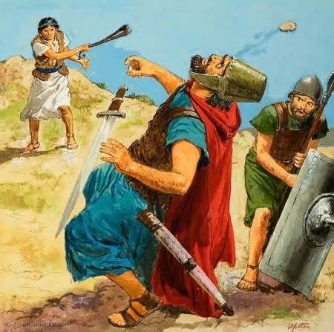
- Goliath was a strong giant leader of the Philistines.
- He carried a spear and a shield for fighting.
- Goliath spoke against God and everyone feared him.
- A young man called David asked for permission from King Saul to fight Goliath.
- David was a shepherd and his father was Jesse.
- David used a stone and a sling to kill Goliath.
- David’s name spread and later he became the second king of Israel.

Activity
- Name the giant who David killed.
- Who was David’s father?
- What was Moses’ work before becoming a king?
- Who anointed David as a king?

WEEK: 7 LESSON 2
How Israelites fell short of God’s expectations
Amos 2:6-16

- Amos was a shepherd before he became a prophet.
- Amos lived in the town of Tekoa in Judah.
- The name Amos means a ‘strong burden’.

Amos’ message to people
Amos preached about God’s judgment for sin.
- He preached against the following;
- Mistreating of the poor by the rich
- Working on the Sabbath day
- Worship of idols
- Fixing of scales wrongly to cheat customers
- Overcharging the poor to cheat them

Activity
- Whose son was Amos?
- How was the work of David similar to that of David?
- Identify any three evil things that Prophet Amos preached against.

WEEK: 7 LESSON 3
FOLLOWING JESUS AS A LEADER

JESUS AS A LEADER
- Who is a leader?
A leader is a person given the authority to lead others.
- What is authority?
Authority is the power/ ability to give orders and make others obey.

- Jesus as a leader was given authority by God –the father to lead us.

Qualities of Jesus as a good leader
- He was kind
- He was honest
- He was tolerant
- He was generous
- Jesus was God-fearing

Qualities of a good civil leader
- Should be a good listener
- Should be honest and helpful
- Should be God-fearing
- Should be hardworking
- Should be exemplary

Activity
Who is a leader?
Give two ways how Jesus was a good leader.
Identify any two qualities of a good civil leader.

WEEK: 8 LESSON 1
JESUS’ AUTHORITY
Mark 9;14-29,
- Jesus had authority over all things on earth.
- He had the authority to perform miracles.
- He had the authority to forgive people’s sins.
- Jesus had the power over nature.
- He had authority over evil spirits.

How did Jesus show his authority on earth?
- He calmed the storm.
- He drove out demons
- He for gave people’s sins
- He rose from the dead
- He healed the blind, the deaf, the dumb and the lame.
- He raised the dead (Lazarus and Jairus’ daughter)

Why did Jesus work miracles?
- To show that He was the son of God.
- To show his power and authority
- To make people believe
- To set people free from Satan’s bondage

Activity
- What is authority?
- What showed that Jesus had power over nature?
- Name any two people that were raised to life.
- Give two reasons why Jesus performed miracles.

WEEK: 8 LESSON 2
CONFIDENCE IN JESUS’ AUTHORITY
Luke 8:22-25
- The early Christians faced many problems.
- But they had confidence that Jesus had authority over the problems
- Who are Christians?
-These are followers of Jesus Christ.
-They are also called disciples.
- Who is an apostle?
Is one of the twelve men who Jesus chose to follow him?

Problems faced by early Christians

- Sickness
- Rejection
- Hunger
- Death
- Persecution
- imprisonment

Problems faced by Christians today

- Sickness
- Poverty
- Hunger
- Persecution
- Imprisonment

How the problems are solved

- By following Jesus’ example
- Being kind to one another
- Forgiving one another
- Believing in God
- Praying to God
- Fasting

Activity
- What is the difference between an apostle and a disciple?
- Name any two problems that were faced by the disciples.
- Mention any two problems that are faced by Christians today.

WEEK: 8 LESSON 3
JESUS’ INSTRUCTIONS AND PROMISES TO HIS DISCIPLES

Mark 6:7-13 , Matthew 2

When Jesus was about to finish his work on earth, he gave power and authority to His disciples.

He gave them the power to do the following;
- To drive out demons/ evil spirits
- To teach heal the sick
- To baptize in His name
- To teach the word of God
- To make all people His disciples

The names of Jesus’ apostles
- Simon Peter and Andrew
- Philip and Bartholomew
- James and John
- Matthew and Thomas
- James son of Alphaeus
- Simon the Patriot
- Judas Thadeus son of James
- Judas Iscariot

Activity
- How many apostles did Jesus have?
- Name any four apostles of Jesus.
- Which apostle replaced Judas Iscariot?
- Give two works that Jesus commanded his apostles to do?

WEEK: 9 LESSON 1
JESUS CHRIST OUR SAVIOUR
AT GETHSEMANE
Mark 14:27-72
Jesus had the Last Supper on Holy Thursday and went to pray in the Garden of Gethsemane.

Events at Gethsemane
- He was filled with great fear and sorrow
- He prayed till. His tears were like blood
- The angel of the Lord strengthened Him
- His disciples fell asleep
- The soldiers were led by Judas Iscariot to arrest Him
- Simon Peter cut off Milchus, the servant’s ear and Jesus put it back.
NB: Judas Iscariot hang himself on the tree and was buried in the field of blood
Activity
- In which garden did Jesus pray from before He was arrested?
- Name the servant whom Peter cut off the ear?
- Which last miracle did Jesus perform before he was arrested?

WEEK: 9 LESSON 2
JESUS’ TRIAL (Mark 14:53-60)
- After Jesus’ arrest, He was taken before the Chief high priest for trial.
- At the trial, Jesus went through terrible suffering as below;
- They told lies against him
- They spat on him
- He was beaten and blindfolded
- They mocked him
- They tore his clothes
- Peter denied Him three times because he feared death.
- Later, Jesus was taken to Pontius Pilate the Roman governor for trial.
- Pontius Pilate washed his hands to how that he was innocent of Jesus’ blood.
- Barabbas is the criminal who was released in place of Jesus.
- Pilate handed over Jesus to be crucified on Good Friday.

Activity
- Which Roman governor sentenced Jesus to death?
- Name the criminal who was released in place of Jesus.
- On which day was Jesus crucified?

WEEK: 9 LESSON 3
JESUS’ CRUCIFIXION AND DEATH

Matthew 27; 32-53, Luke 22:14-9-23

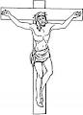
  - Simon of Cyrene helped Jesus to carry the heavy cross.
2. Jesus was crucified on Good Friday.
4. He was crucified on the cross at a place called Golgotha.
5. Golgotha means ‘the place of the skull’.

Events that happened at Jesus’ death
- There was total darkness (an eclipse) from noon.
- The temple curtain tore into two pieces.
- There was an earth quake.
- The graves opened.
- The holy people rose up.

Activity
- On which day was Jesus crucified?
- Name the apostle who betrayed Jesus Christ.
- Why is Joseph of Arimathea remembered in the Bible?
- Identify any one event which happened at Jesus’ death?

WEEK: 10 LESSON 1
JESUS’ BURIAL AND RESURRECTION
John 20:1-20
- Joseph of Arimathea asked for Jesus’ body from Pilate on Friday evening.
- Nicodemus helped him to bury the body of Jesus in a new tomb.
- Jesus spent three days in the grave.
- On Easter Sunday morning, Jesus rose from the dead.

Who were the first people to know about Jesus’ death?
Mary Magdalene
Mary the mother of Jesus
Joann Salome

Importance of Jesus’ resurrection to Christians
- Our sins were forgiven.
- Christians got power over Satan, sin and death.
- Christians have hope for life after death (eternal life).

Activity
- Who helped Joseph of Arimathea to bury body of Jesus Christ?
- On which day did Jesus rise from the dead?
- Name two of women who first knew about Jesus’ resurrection?
- How is Jesus’ death and resurrection important to us?

WEEK: 10 LESSON 2
APOSTLE PETER’S LIFE WITH JESUS
Mark14:66-72
- Simon peter was one of the 12 apostles of Jesus.
- He was the first to be called with his Andrew.
- Peter and Andrew were fishermen and Jesus promised to make them fishers of men.
- Simon was named Peter after answering a question that failed al the apostles.

- What does the name Peter mean?
It means a rock
- Peter promised to die with Jesus but denied Him 3 times.

Peter’s testimony
- Peter, James and John witnessed the transfiguration of Jesus (Matt 17)
- He preached on the day of Pentecost.
- Peter was assigned to take care of the church
- He healed the crippled man at the gate called Beautiful.
- This was his first miracle
- An angel of the lord delivered Peter from prison.

Activity
- What does the name Peter mean?
- What was Peter’s work before he became a disciple?
- Why did Peter deny Jesus three times?
- What was Peter’s first miracle?

WEEK:10 LESSON 3
SELFISHNESS
John 6:5-11
- What is selfishness?
This is an act of caring about oneself and not minding about others.

- Jesus minded about the hungry crowd and fed them with the little he had.

Causes of selfishness

- Greed
- Hatred
- Malice
- Anger
- Envy
- Mistrust
- Jealous
- Misfortune
- Need for revenge

Results of selfishness
- Suffering
- Death of innocent people
- Imprisonment of innocent
- Destruction of property
- Loss of job
- Annoys God

Benefits of unselfishness
- It brings happiness
- Brings love and between one another
- Brings God’s blessing

Activity
- What is selfishness?
- Give two reasons why selfishness is bad.
- State any two dangers of selfish behavior.

